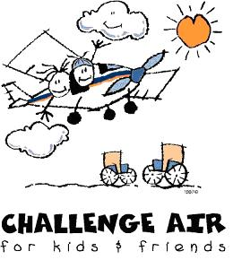
Application Due Dates:
April 1st: For events to be held during the 1st and 2nd quarters of the following year.
October 1st: For events to be held during the 3rd and 4th quarters of the following year.

Return Application to:
Challenge Air
Attn: Programs Committee
8001 Lemmon Avenue Suite 280 Dallas, Texas 75209 (214) 351-3353

Application to Host a Challenge Air “Fly Day”
Name_______________________________________ Email____________________________________
Address______________________________________City______________State _________Zip_______
Proposed “Fly Day” date (need at least 6 months lead time for planning purposes): _________________
Proposed “Fly Day” location/FBO (Please note: Airport must have a control tower):_________________
____________________________________________________________________________________
Proposed Funding/Sponsors: ($5,000 goal):________________________________________________
Number of Volunteers for Planning Committee:______________________________________________
Proposed Participants/Groups (25-50 goal):__________________________________________________
In-Kind Donors Secured?________________________________________________________________
Service Organizations Involved:____________________________________________________________
Pilot Organizations Involved: _____________________________________________________________
Please state why you feel the Challenge Air program would be a good fit for your community. If necessary, use a separate page.
____________________________________________________________________________________
____________________________________________________________________________________
____________________________________________________________________________________
____________________________________________________________________________________
____________________________________________________________________________________
____________________________________________________________________________________

